Grinding Tools without Epoxy

Richard Schwartz
Star Fleet Engineering
Hawthorne California
rev. September, 2000
rev. September 2001

This article is to explain how to make tile grinding tools and dental stone pitch lap foundations without epoxy and to also explain WHY this is a good way to do it.

A common problem that beginners experience when making telescope mirrors is the failure of the edge zone to polish out. This is usually caused by inadequate fine grinding with a solid glass tool. To make matters worse, the beginner is likely to build his pitch lap on the grinding tool so that correcting the grinding problem requires destruction of the pitch lap. Tile tools are superior to plain glass tools because their channels distribute the grits in such a way as to give better fine grinding at the edge of the mirror. (If your glass tool is thick enough, you can channel it and get the same benefits.) Tile tools are easy to make. One supplier of mirror blanks provides two glass blanks with the intent that one of them will be a tool, but with a tile tool and a separate pitch lap foundation of dental stone, you can make it into a second mirror with greatly reduced chance of grief.

Many mirror makers have problems with their tile grinding tools. These problems include
- inability to clean the channels due to the use of hex tiles
- plaster and other materials flaking off of the tool and possibly scratching the glass
- varnish peeling off of the tool or lap foundation after water penetration
- epoxy failing and tiles falling off
- edge tiles grinding too thin and breaking
- plaster does not bond well to the tiles

The tools described here will conquer all of these problems with the right choice of materials and a good fabrication method.

Success in tool making begins with the choice of materials. I prefer the 1 inch square white unglazed mozaic tiles that are available at Home Depot stores here in California (and also in Alberta). The tiles are sold in mats twelve inches by twenty-four inches to make life easier for flooring installers and makers of mirror grinding tools. The mats may be connected by rubber ligaments (California), or by nylon netting (Alberta). There is nothing magic about these tiles, except that they are hard. You can probably do as well with any hard small tiles. The attachment of the tiles to form a mat is a great convenience because the spacing between the tiles is accurately established, straignt channels are assured, and because a connected mat is less likely to move during the molding procedure. Square tiles are preferred over hex; you will quickly discover the reason for this the first time you try to run a scrub brush down the channels. A mat of tiles cost about seven dollars at Home Depot in 1999. While you are there, you should get a tile nipper tool to help you form the circle. For tools larger than eleven inches diameter, you can just remove any tiles that are partly outside the edge of the tool; you do not need a tile nipper.

Dental stone is a plaster-like material. You buy it as a powder, mix it with water and mold it. It then gets hard. The dental stone I use is Modern Materials buff labstone. Dental stone is far superior to plaster: it is harder, it is stronger, and it is water resistant. Dental stone contains no sand or other abrasive grit that might come loose and scratch your optical work. (Note that there is a harder product called “die keen”; I have tried this and found it not to be water resistant.) Dental stone is NOT dental plaster! You can generally find dental stone by looking in your phone book yellow pages under “Dentist Equipment and Supplies”. There you will find a dental equipment supplier who will supply the dental stone (and other unspeakable instruments of sadistic torture and mutilation). I was able to do this in ten minutes in a strange city in a foreign country, so dental stone is not at all hard to get.

Tile tools work best if they are molded to the curve of your mirror. This requires that your mirror blank be already hogged out to the approximate curve you desire. (I generate my curves by slumping the glass on a special mold at high temperature.) You can use almost anything as a tool for hogging out the curve. I have heard of people using bar bell weights, pipe flanges, sub-diameter tile tools, and even flat stones. For hogging out the approximate curve, you do not need great accuracy, as you will never go finer than #120 grit.

To make the tool, use the mirror itself as the bottom of a mold. This makes the tool curve match the mirror curve, and you won’t end up grinding the edge tiles thin and breaking them. Step-by-step, here is what to do:

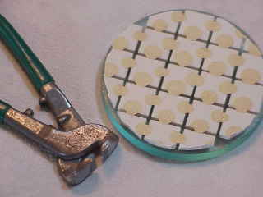
- cut a circle from the tile mat about a quarter inch (6 mm) less in radius than the mirror blank. You don’t need to be careful about getting the tile pattern off center to avoid “zones” because “zones” are formed during polishing, not during grinding. You don’t need to worry about beveling the edges of the tiles if you use the tiles that were recommended above. You don’t need to keep edge tiles for which less than a quarter of the tile area is inside the circle. Use a Swiss Army knife to cut the circle out of the mat, and use the tile nipper tool to remove fractional tiles. IMPORTANT: DO NOT SEPARATE THE TILES. The rubber ligaments or netting will define the spacing between the tiles and establish the channels between them. The tile disk should be clean and free of grease that may interfere with bonding to the dental stone; use liquid dish detergent in hot water to wash dirty or greasy tiles, then rinse well.

- Grease up the front of your mirror blank with salad oil, petroleum jelly, Crisco, or just about any other slippery stuff. Eventually, this will facilitate sliding the tool off of the mirror blank. Cover the greased mirror blank with Saran wrap (“cling film” in the UK). Other plastic films that work well are garbage bags and drycleaner bags. The drycleaner bags are best if the curve is deep and requires stretching of the film. You do not want to allow the tile to contact the grease because that may interfere with the bonding of the dental stone to the tiles. You do not need to worry about forming channels by having grease partly fill the channels; you will form the channels after molding the tool by one of several easy methods. For mirror blanks larger than 9”, it is best to use TWO layers of plastic film with grease or oil between the layers as well as between the bottom layer and the glass.

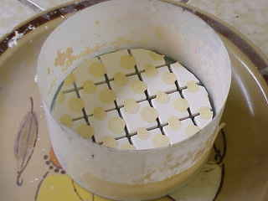
- With the mirror blank face up on a breadboard, make a dam around it. You will want your dental stone tool to be thick enough to not bend or break, so make the dam high enough. I follow the old rule that the thickness should be at least 1/6 the tool diameter. Although you can make the dam of aluminum foil, waxed cardboard or waxed paper, I prefer a strip of mylar drafting film that is tightly secured around the mirror edge with masking tape. I have used the same mylar strip to make more than twenty tools, and it shows no signs of wear. When building your dam, keep in mind that you will be peeling it off of the tool and mirror later.

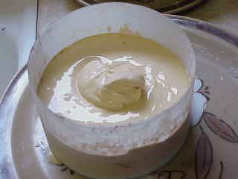
- Place the circular tile mat face down in the mold and carefully center it. There should be about a quarter inch (6 mm) margin all around.

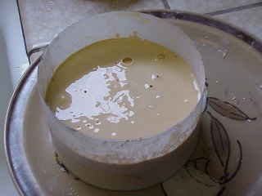
- Mix the dental stone powder with water. The exact proportions are not at all critical. The instructions that are included with the dental stone advocate a very thick mix, but I have found that a little extra water does not harm. If you are making a larger tool over ten inches (30 cm) diameter, you should get helpers to mix several batches of dental stone at the same time. It is hard to mix large batches. It is important to mix all of the dental stone at about the same time.

- Scoop the dental stone mix into the mold on the back of the tile mat (because it should be too thick to pour). If the dental stone is mixed correctly, it will NOT settle flat (see picture).

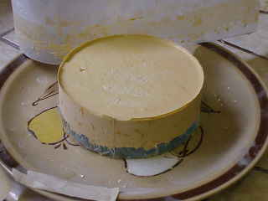
- IMPORTANT: vibrate the mold. The dental stone mix will momentarily become fluid and will slump down so that its back is flat. It will settle into the channels between the tiles. Keep vibrating to get some of the entrapped air bubbles out of the tool. There have been reports of dental stone getting under the tile, so use a bamboo teriyaki skewer to probe the tiles and make sure they are against the bottom of the mold. The skewer holes will quickly close with vibration. Some have suggested embedding the tile mat in grease to keep it from moving and to keep the dental stone from filling the channels between the tiles. However, grease may weaken the bonding between the dental stone and the tile. It is easy to clean the dental stone out of the channels later.

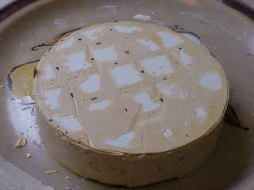
- Wait about five minutes, and begin testing the dental stone by touching the side of the mold. As soon as the material feels firm (certainly no more than fifteen minutes after mixing), remove the dam from the mold and carefully slide the tool off of the mirror. Remove the saran wrap, and clean up the tile face of the tool with a wet sponge. USE A BUCKET, not your sink drain (unless you are skilled in the use of high explosives). Keep sponging so as to deepen the channels between the tiles (I got this idea from tile setters who remodeled our bathroom). If the dental stone has hardened too much for the sponge to work, use a scrub brush. If the dental stone is too hard for the scrub brush, see step (11) below and be thankful that you do not have hex tiles. At this time you may observe that the tool has a beautifully curved surface that precisely matches the mirror blank.

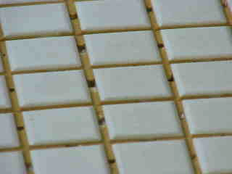
- You may note some deep pockets or cavities in the channels and worry about grits hiding there that may later cause scratches. I have found no such problem. The tool is easily cleaned up with liquid dish detergent and a scrub brush. However, if you must cover those cavities, use a thick creamy slurry of dental stone. Smear it over the tile surface and work it into the cavities with your fingers, let it thicken a bit, and then sponge off the tile surface as described above. If the channels are totally filled, they are easily cleaned up later with the scrub brush or whetstone.

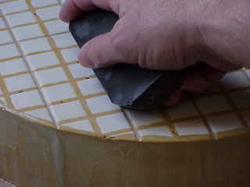
- Set the tool aside. After about a half hour, it will get hot, but not hot enough to be a fire hazard. This is the normal curing action of the dental stone. Once the tool is cooled, dry it off and mark an “X” on each tile face with a Sharpie marking pen. You can now begin grinding. Since the curve of your mirror and tool are already formed, you can begin with grit #220 or #240 on smaller mirrors.

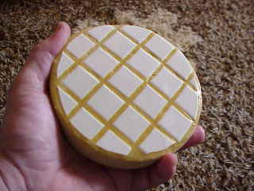
- Cleaning the channels. The best way to do this is while the dental stone is still soft. However, if the dental stone is hardened, you can easily clean the channels with the edge of a whetstone tilted 45 degrees. This will also soften any sharp edges on the tiles, if that is a concern.

- Pitch Lap foundation: Once grinding has established contact between the glass and most of the tiles, you should make your pitch lap foundation. A separate pitch lap foundation allows you to go back to grinding, if needed, without destroying the pitch lap. DO NOT WAIT UNTIL FINE GRINDING IS COMPLETED, or you will be begging for scratches! Making the lap foundation is just like making the grinding tool, except that you do not use tiles. After the foundation is hardened and cooled, clean up the front surface by grinding a wet or two on it with the mirror blank. Then wash it carefully with liquid dish detergent and put it in the kitchen oven at 200 degrees F (95 degrees C) to dry overnight. Mix one part of pitch with five parts turpentine (proportions not at all critical), and brush liberally onto the hot lap foundation. Unlike varnish, this sealer will penetrate into the body of the lap foundation, so you have to use a lot of it. Because this sealer impregnates the dental stone, there is no way for water to penetrate through any scratch or pinhole in the exterior surface, as with spar varnish. Put the sealed foundation back into the oven and let it cook for a day or so at 200 degrees F to drive out the turpentine. Turn the oven off, and when the oven is cool you can take the foundation out and build your pitch lap. Do not worry if the surface seems crazed; the cracks are very shallow and will not compromise your pitch lap foundation. Pitch seems to adhere very well to this penetrating sealer.

These tools and the method of making them have worked well for me for the last several years for tile tools and lap foundations up to 13” diameter. I have taught these methods to attendees at the Telescope Optics Workshop in Bellingham, Washington, and I would like to thank the attendees for positive feedback that improved the procedure. Note that there is NO EPOXY used anywhere in this process! I do not claim that this is the only way to make a tile tool, but it seems to avoid most of the pitfalls of other methods that have been published. I welcome your comments, discoveries, and improvements to these methods. You may reach me by e-mail: richas@earthlink.net.

